2B Displaying Single Data Sets – Lesson 8
Statistics –IQR and the Ogive.

Name: _________________
- What is an ogive?

- Use the following Cumulative Frequency Polygon below.
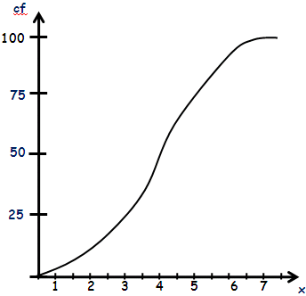

  - What is the median?

  - What is Q3?

  - What is Q1?

  - What is the IQR? [IQR=Q3-Q1]

- Use the following Cumulative Frequency Histogram below.
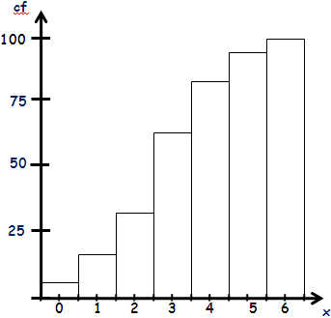
  - Draw the ogive on the diagram.

  - What is the median?

  - What is Q3?

  - What is Q1?

  - What is the IQR? [IQR=Q3-Q1]

- Complete the FDT below.

Score | Class Centre | Frequency | Cumulative Frequency
0 - 4 |  | 7
5 - 9 |  | 17
10 - 14 |  | 28
15 - 19 |  | 30
20 - 24 |  | 15
25 - 29 |  | 3

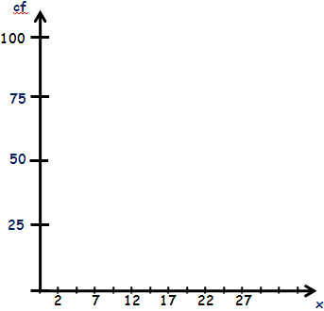
  - Complete the Frequency Distribution Table above.

  - Draw a cumulative frequency histogram.

  - Draw the ogive on the diagram.

  - What is the median?

  - What is Q3?

  - What is Q1?

  - What is the IQR? [IQR=Q3-Q1]

